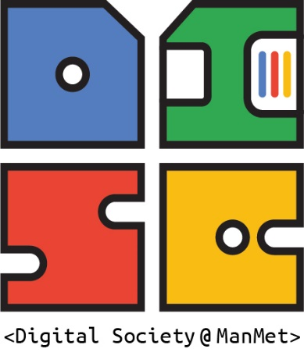**DISC- Digital Society Research Group**

**Research activities**

**2021-2025**

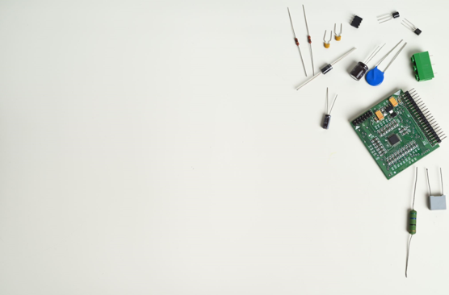

# INTRODUCTION

DISC was formally launched in 2021, when we officially became a research group, bringing together research activities and conversations between staff members in Arts and Humanities and across the university. Drawing on the “Digital Transformations” research group established by Adi Kuntsman in 2015, and developing the work carried out by Tom Brock and Adi Kuntsman to promote digital sociology research in 2016-2020, in 2021 DISC has received a substantial financial investment from the Faculty of Arts and Humanities to bring together “all things digital” and showcase social science research of digital technologies. Despite the difficult post-Covid rebound that had affected all staff and students at MMU, in 2021-22 Adi and Tom put together an impressive festival of digital society research. Since then, the group has grown substantially from a handful of staff to a vibrant cohort of early career and established researchers and international collaborators. In 2024, Tom Brock stepped down as DISC co-lead. Daniel Joseph took on Tom’s role, and has successfully co-led DISC with Adi Kuntsman, shaping the group’s successful expansion and enhancing DISC’s social and academic sustainability.

Currently, DISC offers a wealth of activities and is home to the annual Online Postgraduate Summer School in Digital Politics. Our researchers take part in pioneering work on platform governance, visual digital research, game studies, digital fashion, health informatics, digital harms, and digital environmental sustainability. In 2024, we have set up a new working group, “AI Literacy”, and launched our new website, <https://digitalsociety.mmu.ac.uk/> . In May 2025, we have officially received our “established” status, and expanded our leadership team, which now includes a Deputy Lead, Jessica Elias.

This report looks back at the group’s growth since 2021, leading to its current rich research environment, which includes annual international Visiting Fellowships, the AI Literacy working group, AHEAD public engagement initiative, Digital Politics Summer School, and much more. Next on the horizon- expanding our public profile and strengthening our community links, developing policy interventions and grant capture, and of course, continuing our world leading research and publications.

# EVENTS

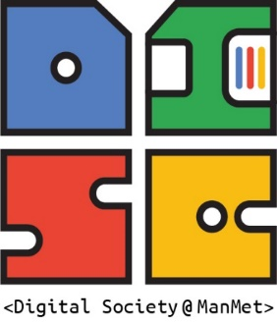

## Digital Society Week

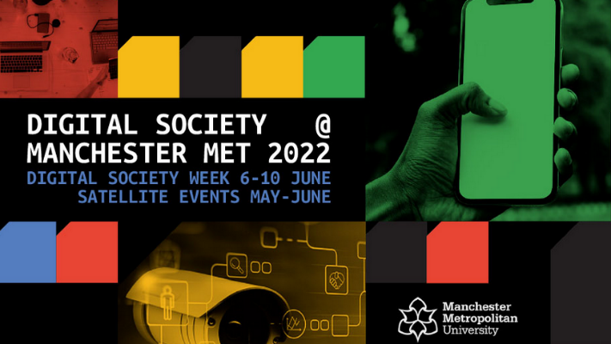In June 2022, Adi Kuntsman and Tom Brock organised a [week-long festival](https://manchesterwire.co.uk/guide/digital-society-mmu-5-unmissable-events/) of research events, exploring the impact of digital technologies on many aspects of our lives, work, and research. Each day focused on one topic: play, research methods, politics, arts and the environment. In addition to the Digital Society week itself, we held many “satellite” events throughout the summer. The festival brought together high-profile UK and international speakers, staff from across the Faculty, and MMU’s [RISE grand challenge](https://rise.mmu.ac.uk/research-internship-grand-challenge-do-digital-technologies-help-or-harm-the-planet-decarbonising-and-decolonising-our-digital-society/), and included a series of high-profile events:

* Monday 6th June | Dr. Daniel Greene, ‘The Promise of Access’ (keynote)
* Tuesday 7th June | Dr. Sara Grimes, ‘The Politics of Children’s Digital Playgrounds (keynote)
* Wednesday 8th June | Professor Ben Light, ‘Using the Walkthrough Method in a Multi-Method Study: An Example from the Covid Sex Lives Project’ (keynote)
* Thursday 9th June | Dr. Ben Gwalchmai, Augmented Reality workshop
* Friday 10th June | Dr. Benedetta Brevini, ‘Are Digital Technologies Good For The Planet?’ (keynote)

## Digital Politics Online Summer School

Established in 2021 in the midst of the Covid-19 pandemic, and directed by Adi Kuntsman since, our [Online Summer School](https://digitalpoliticsmanmet.bloggi.co/summer-school) offers an opportunity for postgraduate students at Manchester Met to meet with other students and early career researchers and to take part in masterclasses led by world class scholars in the field of digital politics, society and media. Over the years, the school has supported networking, nurtured pioneering ideas, and mentored our students through all stages of academic publication from inception, through peer review and to the final publication. 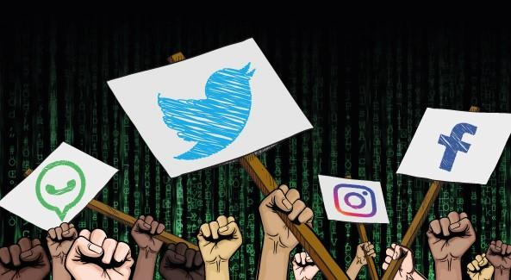Each School is curated by DISC members, sometimes in collaboration with international academics. Each School includes high profile keynote speakers, as well as creative and academic workshops, and also offers an invaluable opportunity for international networking.

* Summer School 2025 (curated by Adi Kuntsman and Jessica Elias): [Visual AI politics/politics of visual AI](https://digitalpoliticsmanmet.bloggi.co/visual-ai-politics-politics-of-visual-ai-digital-politics-summer-school-2025)
* Summer School 2024 (curated by Adi Kuntsman and Jessica Elias): [Digital Harms](https://digitalpoliticsmanmet.bloggi.co/digital-politics-summer-school-2024-digital-harms)
* Summer School 2023 (curated by Adi Kuntsman): [Can we 'reduce, reuse, refuse'.. the digital?](https://digitalpoliticsmanmet.bloggi.co/can-we-reduce-reuse-refuse-the-digital-digital-politics-summer-school-5-6-june-2023)
* Summer School 2022 (curated by Adi Kuntsman with Liu Xin, University of Karlstad): [Digital technologies and the environment](https://digitalpoliticsmanmet.bloggi.co/digital-politics-summer-school-digital-technologies-and-the-environment)
* Winter School 2022 (curated by Adi Kuntsman): [Digital Citizenship and its limits](https://digitalpoliticsmanmet.bloggi.co/event-digital-politics-winter-school-is-coming)
* Summer School 2021 (curated by Adi Kuntsman and Liu Xin, University of Helsinki): Digital Politics, Digital Histories, Digital Futures

## Seminars, talks and workshops

DISC offers regular research seminars, guest talks, roundtables and workshops, in addition to major annual events such as those described above. All these are open to the public free of charge, and often bring together MMU researchers and local, national and international scholars, postgraduate students, and professionals.

Our recent and upcoming events can be found [here](https://digitalsociety.mmu.ac.uk/events/). Some of our online and hybrid events have been recorded and are now available on our YouTube [channel](https://www.youtube.com/@DISCDigitalSocietyatManMet).

## Away days

While most of our events are externally facing, aimed at academic dissemination, networking and knowledge exchange, DISC also holds internal staff development events and away days. Initially, our Away Days served to bring together DISC members and learn about our diverse research. In 2025, we have reoriented our efforts to focus on creative public engagement, while supporting staff wellbeing. In June 2025, DISC went to Trafford Ecology Park, to spend a day in a nature-inspired event centre, alternating lake walks with a preparation of AI Literacies toolkits, in collaboration with an Indian artist and illustrator, [Sonaksha](https://www.sonaksha.com/).

# INTERNATIONALISATION AND NETWORKING

## International conferences, visits and invited fellowships

Our members regularly attend international conferences, collaborate with international research groups, take part in invited international visits, and invite international collaborators to MMU. Here are a few highlights of such activities:

* Jessica Elias presented her work in 2025 in a collaborative event, organised by the Center for Digital Society at Universitas Gadjah Mada (Indonesia); and attended conferences in Italy, Finland, and Lithuania with the European Group for the Study of Deviance and Social Control.
* Hilde Heim arranged for Professor Ellie Rennie from RMIT to visit in 2023 and give a public lecture on blockchain and digital decentralised communities.
* Abu Sadat Muhammad Sayem attended multiple conferences in Bangladesh and Denmark, and collaborated with fashion researchers in Bandgladesh
* Geoff Walton visited San Jose State University 2022 and 2023, as part of his ongoing collaboration and a joint PhD programme with SJSU that he leads
* Occulta Dama attended the Indiana University Annual interdisciplinary conference and the University of Pennsylvania Empathy and recognition Conference
* Tom Brock visited Finland and Norway, and held a Visiting Professorship at the Department of Media and Communications, University of Sydney (the latter postponed due to Covid)
* Daniel Joseph was an invited Fellow at the University of Oslo in 2023.
* Adi Kuntsman held a visiting Fellowship to the Aleksanteri Institute, University of Helsinki (postponed due to Covid), invited Visiting Fellowship to Karlstad University in 2023; and visited Sweden, Netherlands and Finland in 2023, 2024 and 2025 to give Masterclasses and take part in research networking.

## Visiting Fellowships

In 2024, we launched a funded Visiting Fellows scheme, to support short visits by international researchers. who would like to spend some time at Manchester Metropolitan University and collaborate with our members. We were delighted to welcome Dr Nataliia Laba from University of Groningen, who is collaborating with Adi Kuntsman and Jessica Elias on research about visual AI; and Dr Katherine Clare Mackinnon from University of Copenhagen, who is collaborating with Daniel Joseph on research about platform history.

## International collaborations

As our international presence grows, we are now in a position to direct efforts to developing more focused international collaborations. At present, our members have ongoing individual links with researchers in Bangladesh, Canada, Finland, Netherlands, and Sweden. We will build on these to develop collaborations that involve multiple DISC members.

# PUBLICATIONS

All DISC members are research active and are regularly generating high profile publications.

## Books

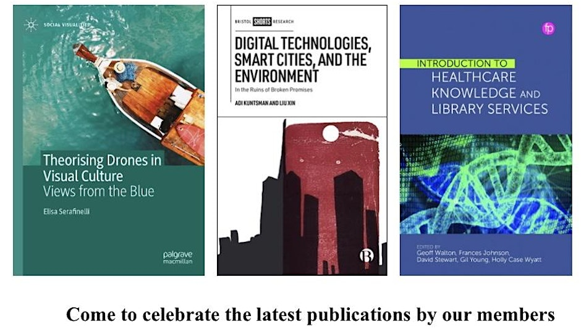In 2024-2025, DISC held a celebratory launch of new books by our members.

[**Theorising Drones in Visual Culture: Views from the Blue**](https://link.springer.com/book/9783031752544) authored by Elisa Serafinelli significantly contributes to the fields of Digital Media and Visual Studies by synthesising diverse studies on drone-generated visuals. It offers readers a comprehensive exploration and specific examples that ground theoretical insights in new and innovative visual applications.

[**Introduction to healthcare knowledge and library services**](https://www.cambridge.org/core/books/introduction-to-healthcare-knowledge-and-library-services/4765F6E194459FA88BA2E0B7BF550EA1), coedited by Geoff Walton, , Frances Johnson, David Stewart, Gil Young, and Holly Case Wyatt, Cambridge University Press. Winner of CILIP’s Knowledge and Information Management prize. Brings together health information practitioners and researchers with a variety of experience across health information work within knowledge and library services in the NHS.

[**Digital Technologies, Smart Cities and the Environment: in the ruins of broken promises**](https://bristoluniversitypress.co.uk/smart-cities-and-the-environment), co-authored by Adi Kuntsman and Liu Xin. Drawing on academic scholarship and two case studies from Manchester and Helsinki, this timely and accessible book examines what happens when these promises are broken, as they prioritise technological innovation rather than environmental care.

## Journal articles

Below is a small selection of recent journal articles by our members:

Ahsan, M., Teay, SH., Sayem, ASM., Albarbar, A., 2022. 'Smart Clothing Framework for Health Monitoring Applications', Signals, 3 (1), pp. 113-145. <https://www.mdpi.com/2624-6120/3/1/9>

Brock, T. (2025) '[Ontology and interdisciplinary research in esports](http://dx.doi.org/10.1080/17511321.2023.2260567).' *Sport, Ethics and Philosophy*, 19(1) pp. 48-64.

Brock, T., Crawford, G. (2024) '[The esports experience economy: a multiple case study of esports events, peripherals and fashion](https://doi.org/10.1108/INTR-02-2024-0138).' *Internet Research*,

Brock, T. (2021) '[Videogaming as Craft Consumption](https://journals.sagepub.com/doi/full/10.1177/14695405211016085).' *Journal of Consumer Culture*, 22(3) pp. 598-614.

Elias, J. (2025) '[Towards a digital zemiology](http://dx.doi.org/10.1332/26352338y2024d000000014).' *Justice, Power and Resistance*, pp. 1-17.

Heim, H. (2022). Digital fashion revolutions: Supply chain transparency, digitalisation and the non-disclosure paradox. The Journal of Fashion Practice Special Issue. https://doi.org/10.1080/17569370.2022.2118975 2022

Joseph, D., Bishop, S. (2024) '[Advertising as governance: the digital commodity audience and platform advertising dependency](https://doi.org/10.1177/01634437241237935).' *Media, Culture and Society*, 46(6) pp. 1269-1286.

Joseph, D., Nieborg, D., Young, C.J. (2023) '[One big store: source diversity and value capture of digital games in national app store instances](https://ijoc.org/index.php/ijoc/article/view/21476).' *International Journal of Communication*, 17pp. 7246-7264.

Joseph, D. (2021) '[Battle Pass Capitalism](https://journals.sagepub.com/doi/full/10.1177/1469540521993930).' *Journal of Consumer Culture*, 21(1) pp. 68-83.

Kuntsman, A., Martin, S., Miyake, E. (2023) 'Introduction.' *Digital Disengagement: COVID-19, Digital Justice and the Politics of Refusal*, pp. 1-16.

Serafinelli E. (2022): Imagining the Social Future of Drones, Convergence. <https://doi.org/10.1177/13548565211054904>.

Serafinelli E. and O’Hagan L. A. (2022): Drone Views: A Multimodal Ethnographic Perspective, Visual Communication. <https://doi.org/10.1177/14703572211065093> .

Walton, G. (2024) '[Investigating information literacy: fool’s errand or new message?](http://dx.doi.org/10.11645/18.1.589).' *Journal of Information Literacy*, 18(1) pp. 78-83.

Walton, G., Pointon, M., Lackenby, M., Barker, J., Turner, M., Wilkinson, A. (2022) '[Information discernment and online reading behaviour: an experiment](https://www.emerald.com/insight/content/doi/10.1108/OIR-02-2021-0101/full/html).' *Online Information Review*, 47(3) pp. 522-549.

# EXTERNAL GRANTS

**Geoff Walton**: Co-1 - AHRC Untold stories: NHS 75th anniversary AHRC £24,950.81. Co-I - Apex Engage and ERDF (Innovation Voucher) Apex Engage/MMU UX Project £13,214.63 (plus VAT)

**Abu Sadat Muhammad Sayem**: Principal Investigator, AHRC Digital Fashion Network 2023-24 (£43K), <https://digitalfashionnetwork.net/about/>; Co-investigator, Circular Economy in Bangladesh’s Apparel Industry (CREATE), 2022-2027 , <http://createproject.aust.edu/researchers/> ; Principal Investigator, GCRF QR 2020/21 (£26.4K): Research Capacity Building and Promoting Sustainable Fashion and Textile Practices in Bangladesh

**Elisa Serafinelli:** 2022 Strategic Research Support Fund UNIVERSITY OF SHEFFIELD Sociological Studies Initiative: ‘Views from the Blue’ Drone visuals exhibition. (£5.000). 2021 WARP (Women Academic Returners’ Programme) UNIVERSITY OF SHEFFIELD Sociological Studies Initiative: Manage a Research Associate to carry on working on my AHRC Leadership Fellowship’s fieldwork, admin, and pathways to impact during my maternity leave (£9.810).

# POSTGRADUATE RESEARCH

DISC has a small but growing community of postgraduate students. Many of our staff have multiple PhD completions (for example, Tom Brock -3 completions, Adi Kuntsman- 5 completions) and extensive experience examining PhD dissertations internally and externally. Building on our very successful Digital Politics PhD pathway, established in 2020 at the Department of History, Politics and Philosophy, DISC is currently actively seeking new PhD students, and welcomes current PhD students at the Faculty to join our events and activities.

# PUBLIC ENGAGEMENT

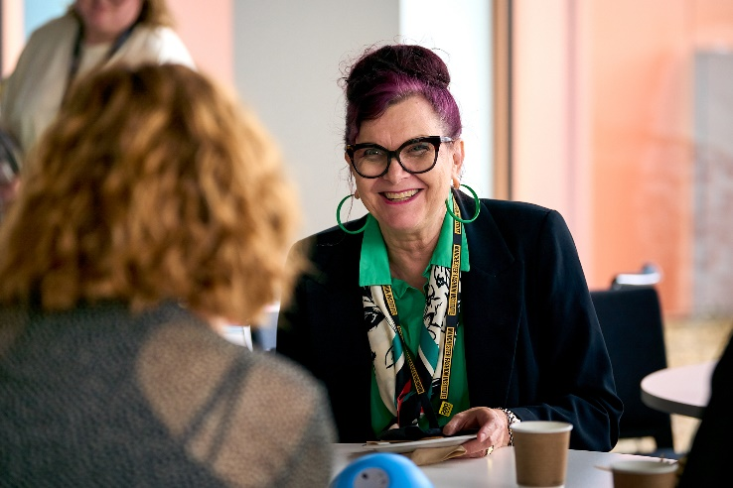DISC members regularly engage with stakeholders, businesses and communities, sharing their research findings and knowledge. Hilde Heim and Abu Sadat Muhammad Sayem are working extensively with digital fashion businesses and digital fashion supply chains. Geoff Walton regularly engages with NHS professionals in the field of heath informatics and information literacy. Adi Kuntsman collaborated with the [Sunlight Doesn’t Need a Pipeline](https://sunlightdoesntneedapipeline.com/) network to explore digital environmental sustainability in Manchester and globally; and is currently involved in the Future Everything initiative, “[Nature on the Board](https://futureeverything.org/news/nature-to-join-futureeverything/)”. Most recently, Adi Kuntsman and Jessica Elias have led a series of [AHEAD-funded public engagement activities](https://ahead.mmu.ac.uk/2025/05/14/lets-talk-ai-literacy/), in collaboration with the digital sociologist and AI artist, Sam Martin, to develop visual AI literacy and combat AI-driven misinformation. These activities resulted in a new collaboration with the Manchester Cathedral, Manchester Faith Leaders Forum and GMCA Integrated Care Board.

# AI LITERACIES

In 2024, members of DISC launched a new initiative – the [AI literacy working group](https://digitalsociety.mmu.ac.uk/ai-literacy/) – to address the urgent need to understand and theorise our engagement with AI in all spheres of social, cultural and political life. “AI literacy” (or even “literacies”) extends far beyond the technical understanding of how artificial intelligence and associated technologies work. AI literacy includes

* a novel theorising of risks and responsibilities that come with adopting AI tools into education
* an analysis of new challenges that come with the automation of major political and business decision-making
* challenges posed by AI to creative practice and intellectual processes
* the environmental footprint of training and operating AI systems

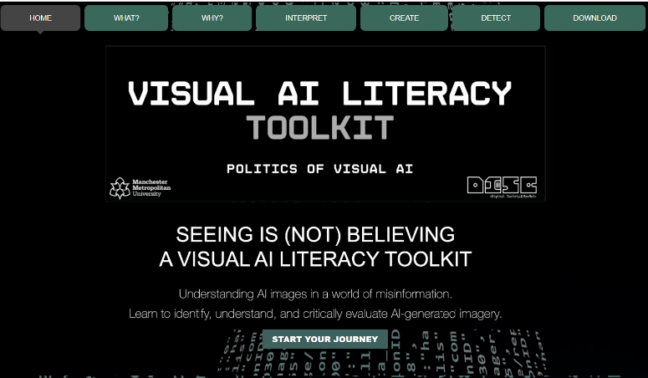In 2025, the AI Literacies theme helped shape and consolidate our activities: our public engagement project and the Digital Politics Summer School were both dedicated to visual AI literacies; including the [Visual AI Literacy platform prototype](https://www.visualailiteracy.com/), developed by Sam Martin, and the [expert webinar on visual misinformation](https://youtu.be/La5AbqflSzU). Our Away Day took shape of an “AI Literacy Lab” and was dedicated to developing AI Literacy toolkits across different disciplines (sociology, criminology, media studies, philosophy, fashion, education) and thematic areas. Our members coined several terms, to conceptualise the multiplicity of AI literacies: cognitive AI literacy, sonic AI literacy, environmental AI literacy, political and economic AI literacy, visual AI literacy. In 2025-26, we will further develop our presence, expertise and public engagement around AI literacies.

Adi Kuntsman (DISC Co-Lead)  
Daniel Joseph (DISC Co-Lead)  
Jessica Elias (DISC Deputy Lead)

July 2025

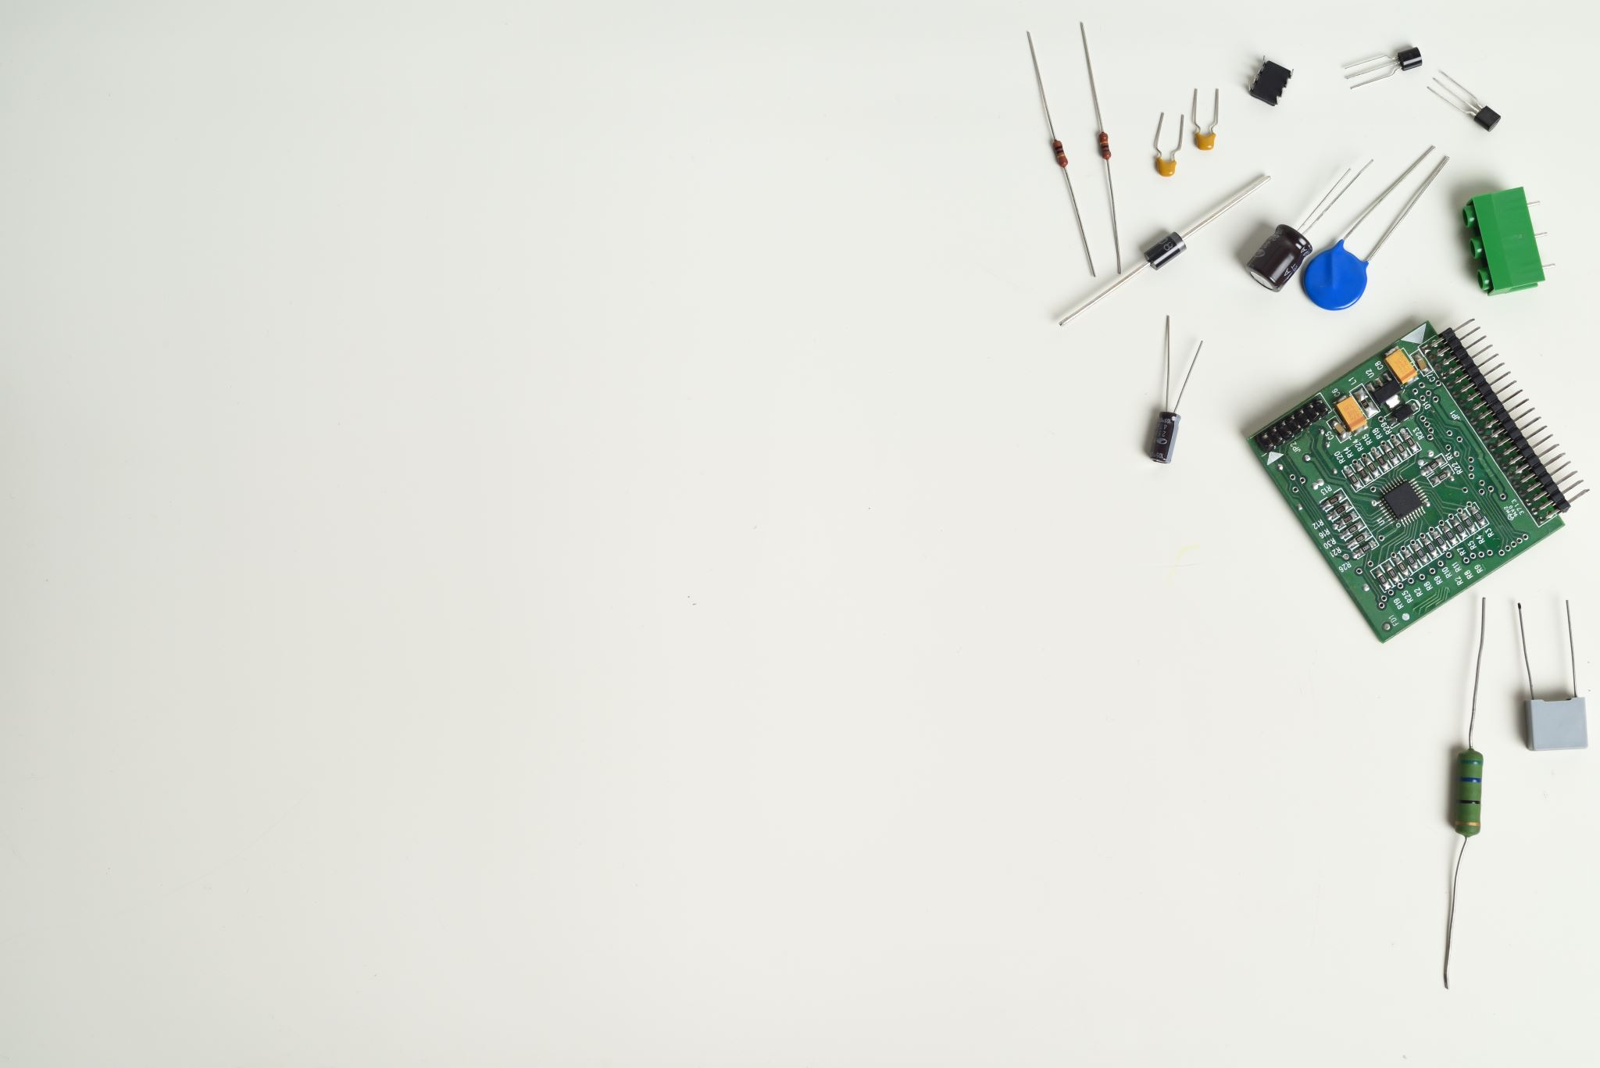

To follow our activities, please visit our website, <https://digitalsociety.mmu.ac.uk/>